KENDRIYA VIDYALAYA NO.1 REWA
ADMISSION FOR SC/ST CANDIDATE
CLASS 11
SESSION-2020-21

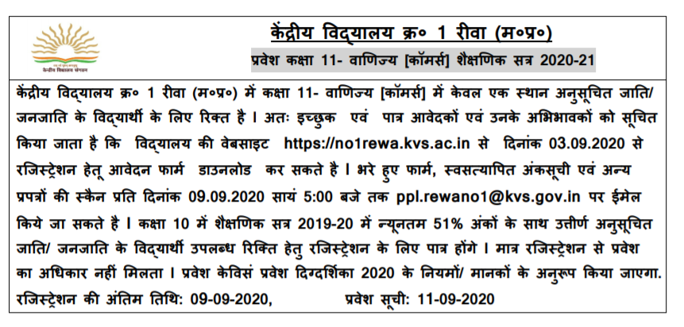


KENDRIYA VIDYALAYA NO.1 REWA
REGISTRATION FORM FOR CLASS-XI,SESSION-2020-21

1. Name of the student (in block letters):……………………………………………………………………………………………..
2. a.Father’s Name: ……………………………………………………. Mother’s Name: ………………………………………………..
b.Father’s Occupation: …………………………………………… Mother’s Occupation: ………………………………………..
c.Number of transfer(previous 7 years)………………………………………………………………………………………………
3. Date of Birth: ………………………………(in words): ……………………………………………………………………………….
4. a. Category (SC/ST/PH):……………………………………..(in case of SC/ST/PH attach Certificate)
5. Residential Address: ………………………………………………………………………………………………………………………
Mobile No. 1.………………………………………………….2…………………………………………..
6. Percentage Obtained (Class 10th 2020): ……………………………………………………….. (Attach internet mark sheet)
SUBJECT | HINDI(002) | ENGLISH(184) | MATHS Standard(041) | MATHS Basic(241) | SCIENCE(086) | SOCIAL SCIENCE(087) | TOTAL
MARKS Obtained

7. Achievement in sports (Regional/National/SGFI/District) YES/NO (if YES attach certificate)……………..
8. Achievement in NCC/Scout Guide(Rastapati/Rajapal/TritiyaSopan): YES/NO (if YES attach certificate)…………..
9. Name of the School and Board from where class 10th passed: ……………………………………………………………………….
10. Please tick optional subject combination in desired Commerce stream:
Stream | Compulsory subjects  (as offered by KV No.1Rewa) |  |  | Optional Subjects
Commerce | English | Accountancy | Business Study | Maths/IP/Hindi | Economics/Political Science
Subject Desired
(Write preferences of subject in Commerce stream)
I hereby undertake that I will not make any request for the change in allotted section, stream and subject in future.
Signature of the Parent Signature of the Student
Office use:
Parent’s Service Category:……………………………………………………
Eligible for the stream: ...............................................................................
Eligible for the Subject: ………………………………………………………………………….

I/C Admission Principal

List of Documents to be scanned and send with application form-
- Class X mark sheet of student
- Service certificate of parent
- Transfer details of parent
- Caste certificate(SC/ST/PH)
- Residence proof
- PH certificate
- Achievement in sports
(Regional/National/SGFI/District)
- Achievement in NCC/Scout Guide(Rastapati/Rajapal/TritiyaSopan)
- Aadhar ID/Samagra ID/Photo

